**REPORT ON THE ANALYTICS TOOL FOR**

**E- COMMERCE BUSINESS.**

**INTRODUCTION**

Ecommerce analytics is the process of gathering data from all areas that have an impact on your online store and using this information to understand the trends and the shift in consumers’ behavior to make data-driven decisions that will drive more online sales.

With the increase in consumer demand, the E-commerce space has boomed. This also lead to an increase in fierce competition in today's online marketplace. The ecommerce industry sells a diverse product line of grocery items and merchandise products, such as food, pharmaceuticals, apparel, games and toys, hobby items, furniture and appliances.

The key drivers of success over the next decade will be centered on building a deep understanding of and connection to the empowered consumer, and the only way to understand consumer behavior is to measure and analyze. The analysis of such industry is of great importance as it gives insights for the sales and profits of various products.

These insights will provide direction to optimize consumer experiences across discovery, acquisition, conversion, retention, and advocacy.

**What are some of the insights you can get from Enhanced Ecommerce?**

Shopping Behavior Report

Product Performance Report

Sales Performance Report

Marketing data.

**LITERATURE SURVEY**

Electronic commerce (EC) is growing rapidly, and offers a diversity of related issues to investigate. E-commerce is an activity of selling or buying products over online services. E-commerce allows firms to have an opportunity of facing wider customers. With E-commerce, customers can shop at any place at any time. E-commerce improves sales and profits of firms.

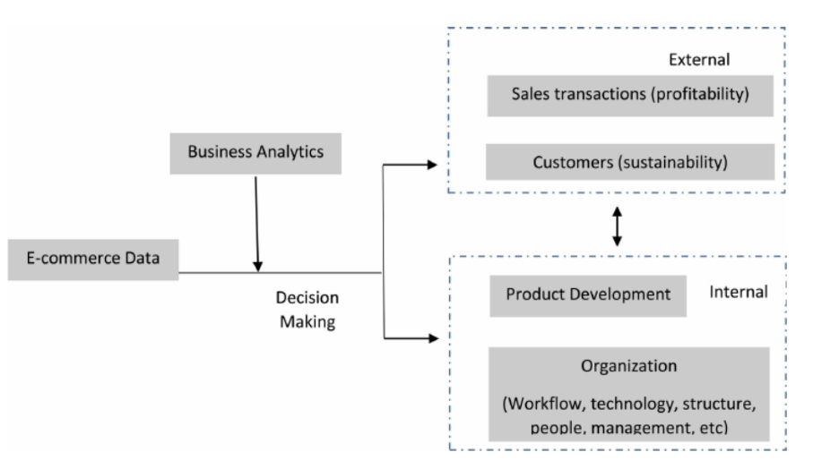Business analytics (BA) has been defined as the use of data to make more evidence-based business decisions.

BA could help decision making which improves external sales, customers' profiles and satisfactions, and enhance internal product development, technology, and organizational workflow For example, the analysis results could identify the customer shopping patterns which help customer's online shopping. BA could also provide real-time recommendations during customers' transactions by tracking customers' clicking. It could also find the issues or improved areas by digging into the log data of management systems which may lead to technology updates, new organization workflows etc.

EXISTING PROBLEM:

In E-commerce, the current challenge is determining how to provide a sustainable competitive advantage through a better understanding of target customers. Customers are most important in E-commerce. The quality of an E-commerce is affected by the unpredictability of e-customer behavior, As per our findings, customer preferences and customer personalization need further researches. The challenge associated with customer personalization is the unpredictability of e-customer behavior. Customer personalization needs to improve.

PROPOSED SOLUTION:

Proper visualization of data so as to find proper statics of how the region and the products for sale have performed and we can take necessary actions to improve the same. We have also shown how discount and sales have affected the profit.

**THEORITICAL ANALYSIS:**

**SOFTWARE REQUIREMENTS:**

Create a reference video and submit the project files

Strat creating the dashboard

Clean and analyse the Data set

Get the data sets

Download Cognos Analytics

Create an IBM initiative account

* IBM Cognos Analytics
* IBM Cloud
* HTML , Java Script
* CSS

**RESULT:**

Following are the results of analysis performed using IBM Cognos Analytics.

1. Analysis on sales and discount:

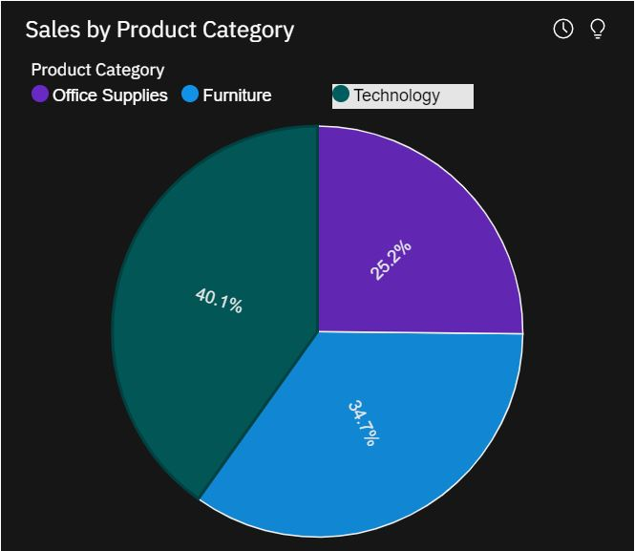***PRODUCT VS SALES:***

This pie chart gives us the idea about the product category that was sold the most. One could see those products that classify under technology domain accounts to the maximum sale i.e., 40.1%, followed by furniture category which holds 34.7% of total sales. Office supplies occupy the lowest start with 25.2% of total sale value.

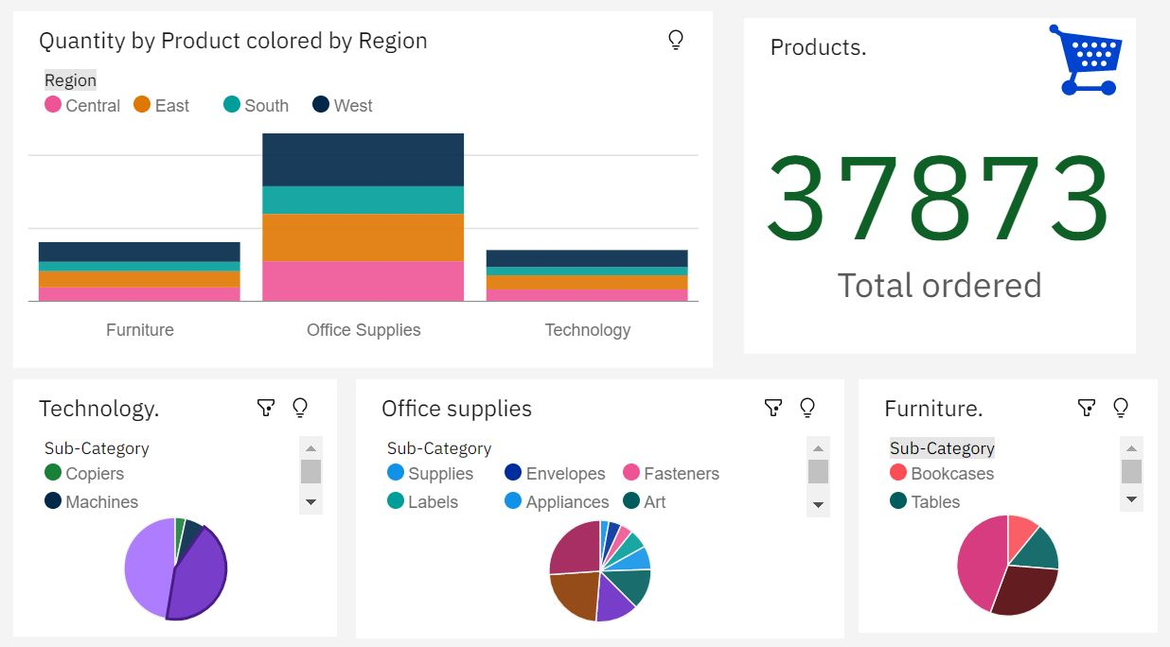***PRODUCT VS QUANTITY:***

The above dashboard focuses on the quantity of products ordered. The first graph in the top left quadrant elaborates on region wise and category wise distribution on product quantity. The data is represented in stacked column format with regions colored. The pie charts depicted below elaborates the quantity on sub categories. The conclusion we could draw from the above is that phones, binders and furnishings have been ordered the greatest number of times under technology, office supplies and furniture respectively. The tile on top right corner summarizes the total number of products ordered which is 37873.

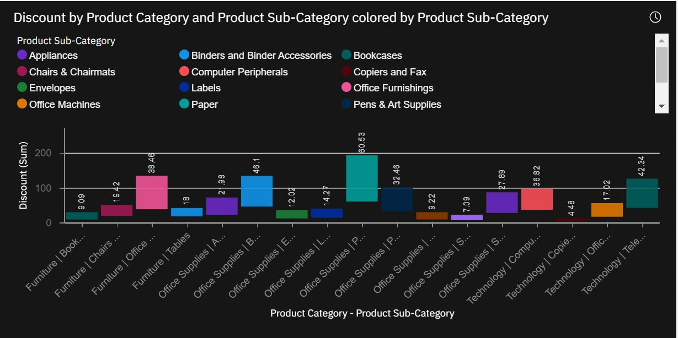 ***PRODUCT VS DISCOUNTS:***

This graph summarizes the discounts offered on various products. The bars are colored with sub category of products under three major categories: technology, office supplies and furniture. Paper was offered the highest discount per se and office supplies category was allotted with highest discount amount. We can also see that despite having less discount, products that come under technology category have incurred more sales.

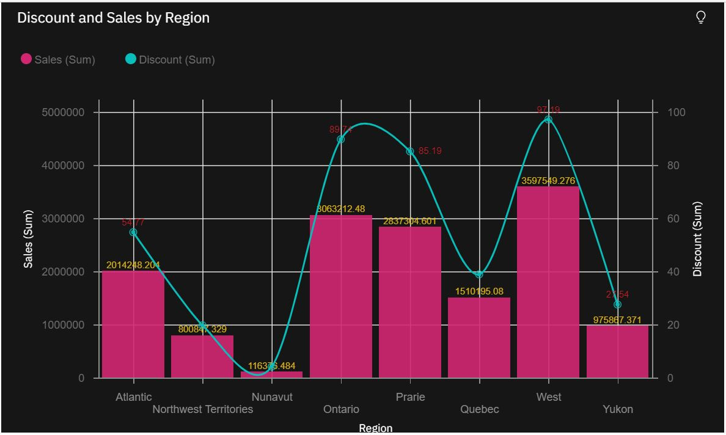***DISCOUNT VS REGION:***

1. Analysis of profits:

***OVERVIEW OF PROFITS:***

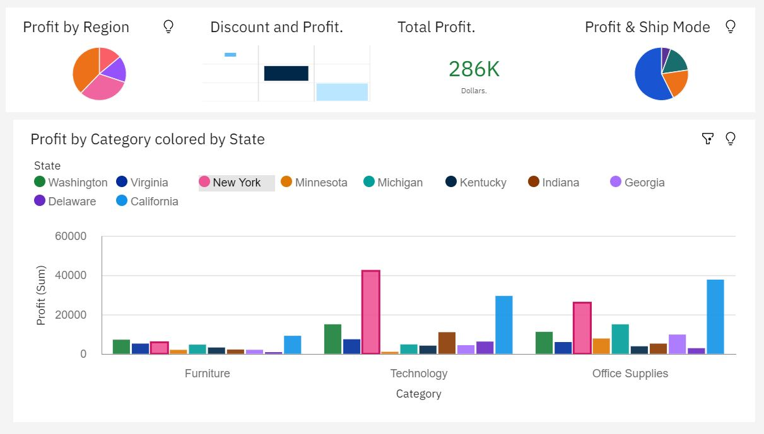

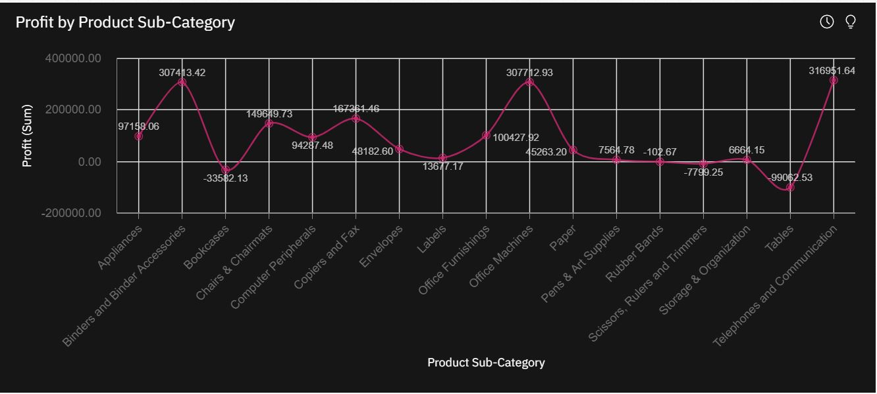***SUB-CATEGORY WISE PROFIT:***

1. Region wise analysis:

***EAST REGION***

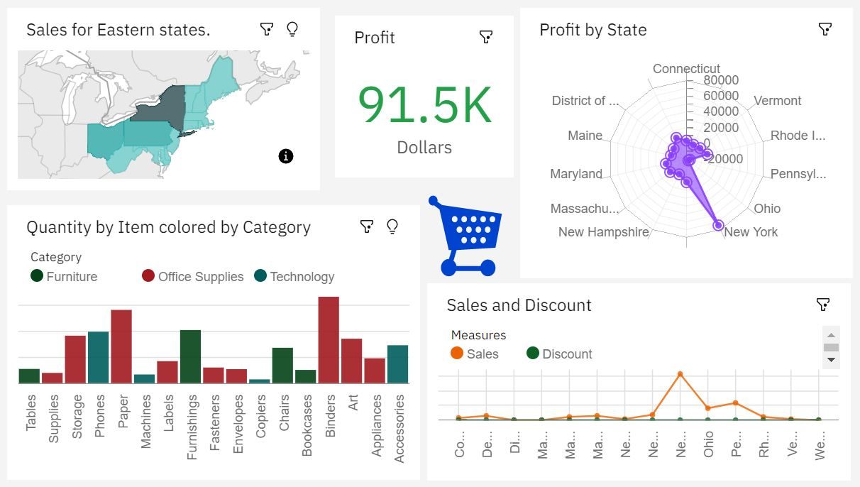

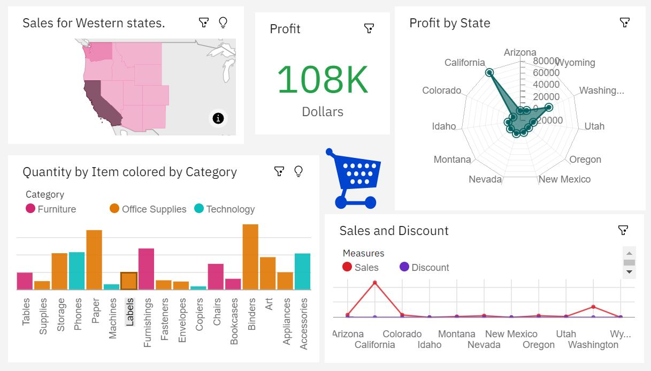***WEST REGION:***

***SOUTH REGION:***

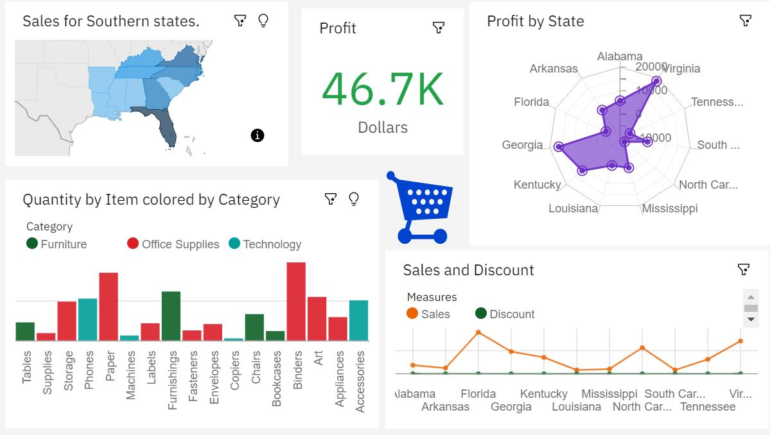***CENTRAL REGION:***

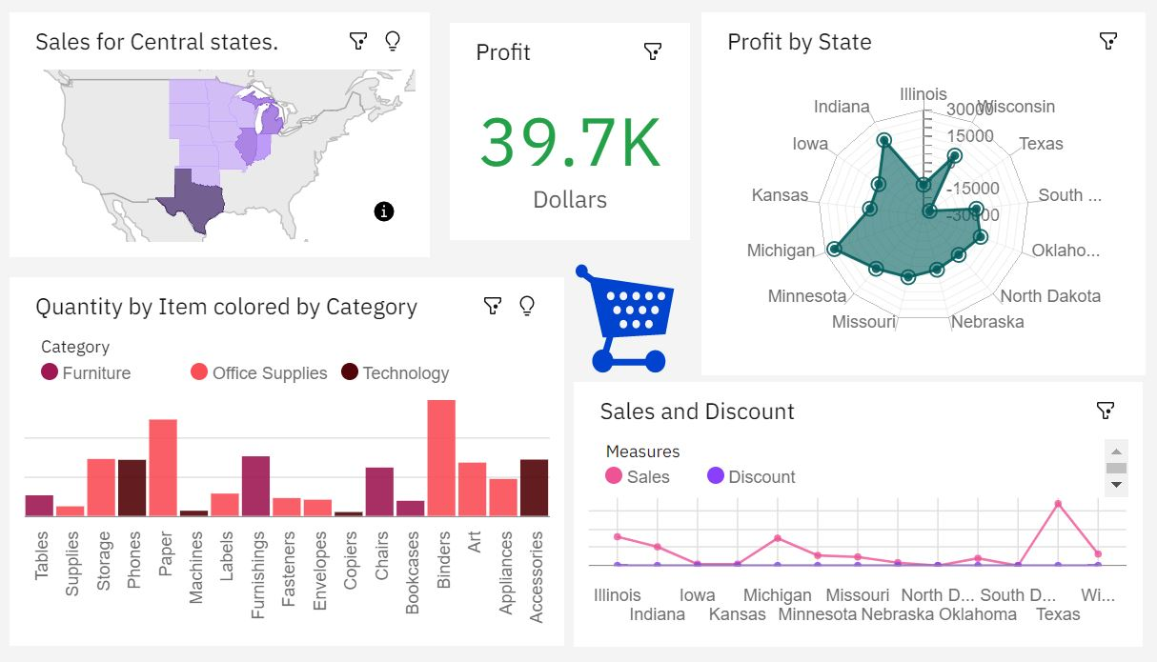

1. Shipping modes:

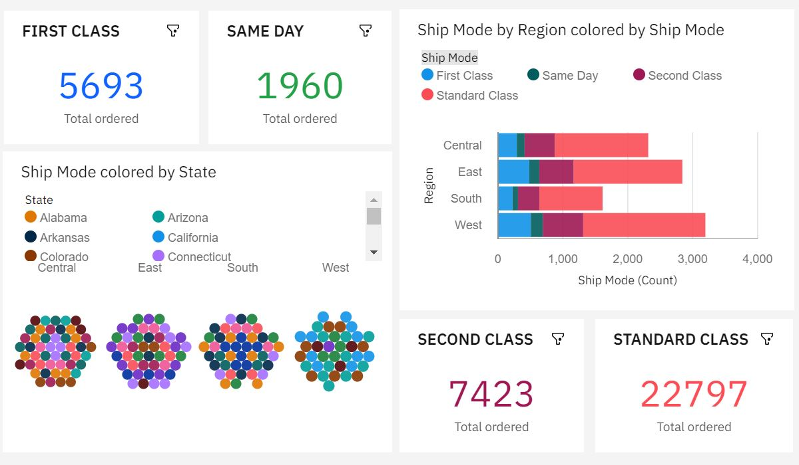

1. Customer segment wise analysis:

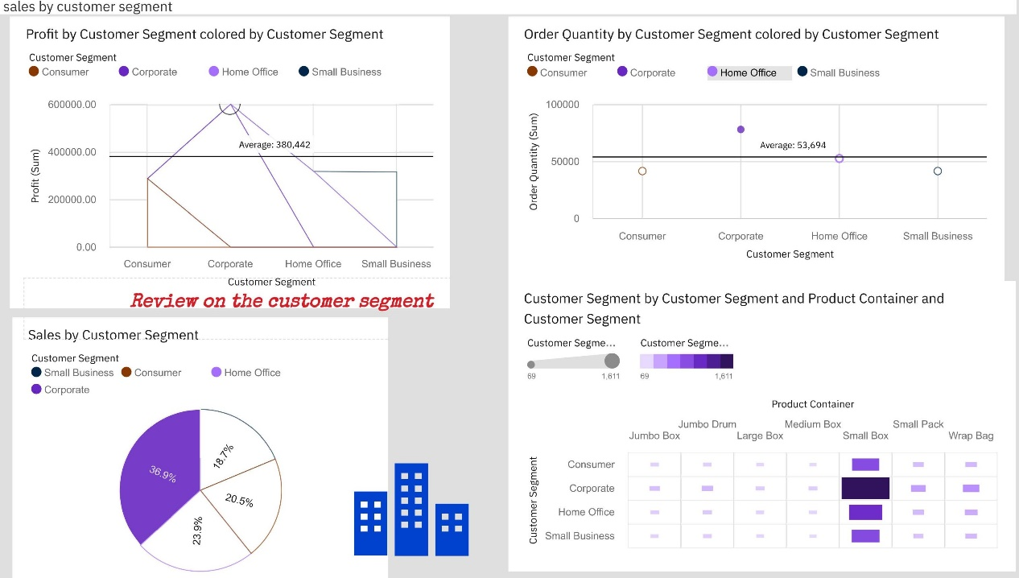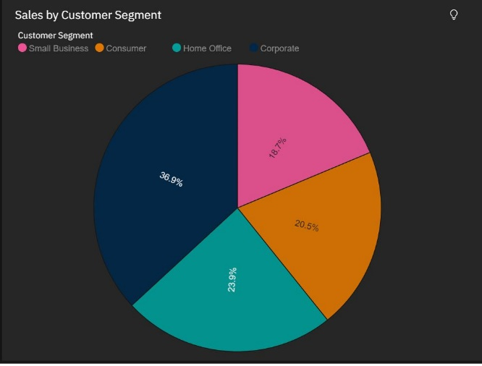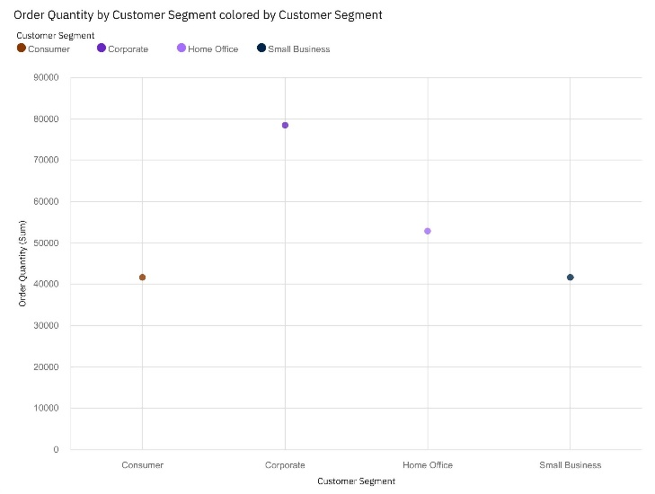

1. Containers and packages:

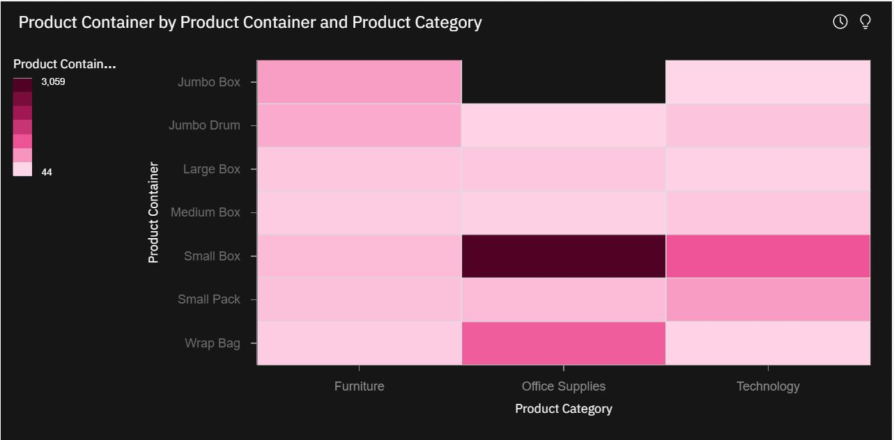***CONTAINERS USED FOR SHIPPING***

***CONTAINERS VS PRODUCT TYPE:***

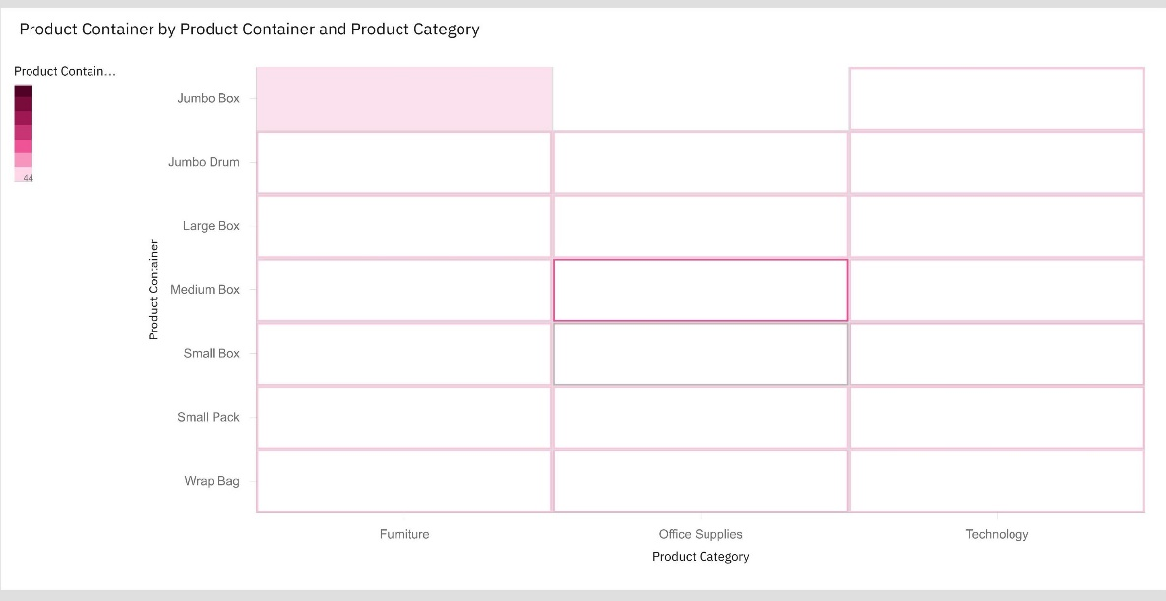

**ADVANTAGES:**

* A Larger Market
* Customer Insights Through Tracking and Analytics
* Fast Response to Consumer Trends and Market Demand
* More Opportunities To "Sell"

**DISADVANTAGES:**

* Need For Internet Access
* Lack Of Tactile Experience
* Many consumers still prefer the personal touch

**APPLICATIONS:**

*Retail and Wholesale*

Ecommerce has numerous applications in this sector. E-retailing is basically sale of goods and services through online stores designed using virtual shopping carts and electronic catalogs

*Online Marketing*

This refers to the gathering of data about consumer behaviors, preferences, needs, buying patterns and so on. It helps marketing activities like fixing price, negotiating, enhancing product features, and building strong customer relationships as this data can be leveraged to provide customers a tailored and enhanced purchase experience.

*Can boost customer experience with the data found from the statistics*

The relations between various parameters could be analyzed and exploited effectively to enhance customer experience and impact profits too.

**CONCLUSION:**

Thus we have analyzed the data and created dashboards for the user to view the trends in the supply ,profit of his/her goods. We have a user friendly website for the ease of understanding the statistics such as growth/potential of the business in the market. Here the bird's eye view of the current trend of the market can be analyzed. The unique and an access friendly dashboard which will help him/her understand and analyze the data in-depth detail and can strategize their business accordingly.

**FUTURE SCOPE:**

Consumers continue to desire their products, services etc. to continuously be better, faster, and cheaper. In this world of new technology, businesses need to accommodate to the new types of consumer needs and trends because it will prove to be vital to their business’ success and survival. E-commerce is continuously progressing and is becoming more and more important to businesses as technology continues to advance and is something that should be taken advantage of and implemented.

Successful e-commerce will become the notion which will be inseparable from the web because e-shopping is becoming more and more popular and natural. Thus, prevailing to future trends, e-commerce will have huge potential growth in sales and promotion especially during COVID-19.

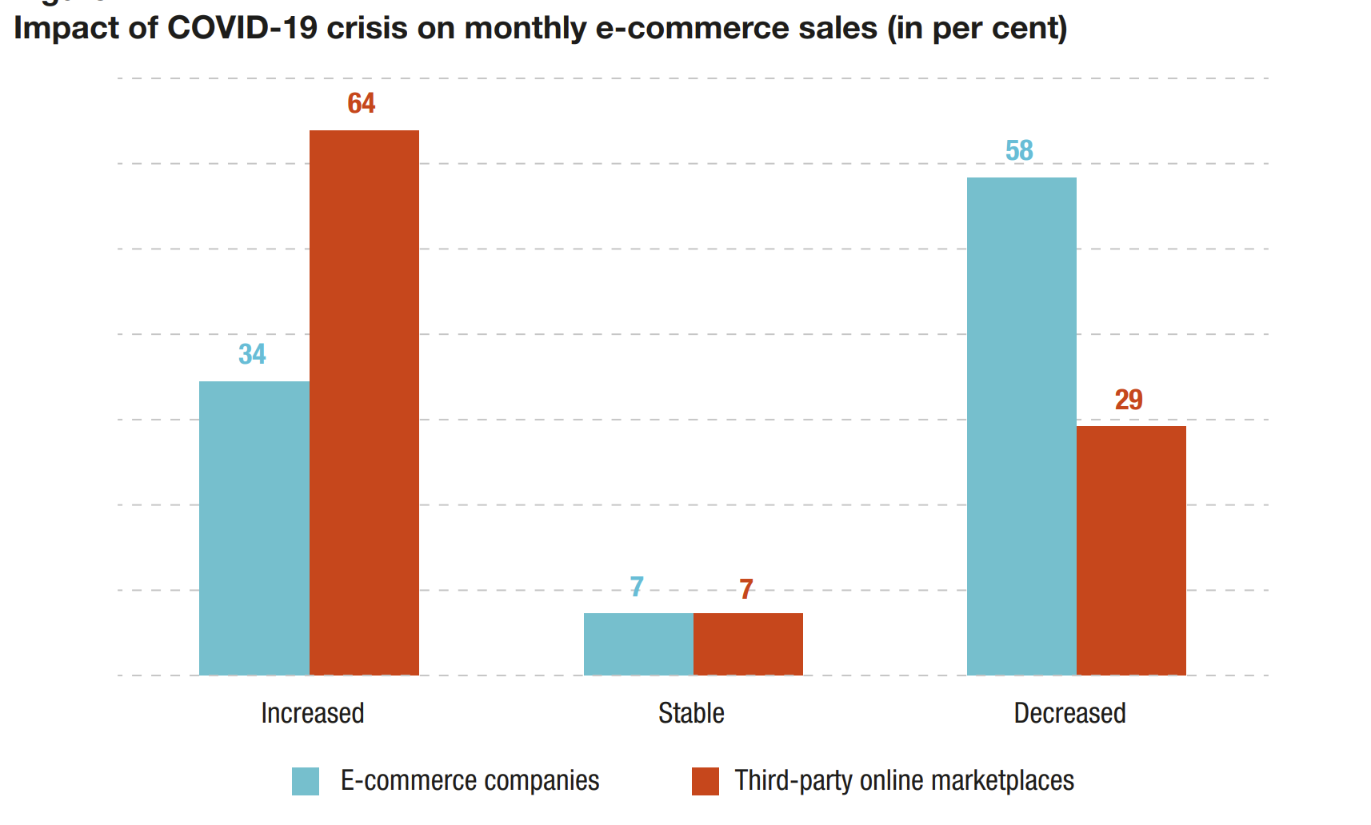

The pandemic has accentuated the trend towards greater adoption of social media and growth in sales through e-commerce websites. Shifts in consumption habits have also been observed, driven by the need for sourcing essential items.

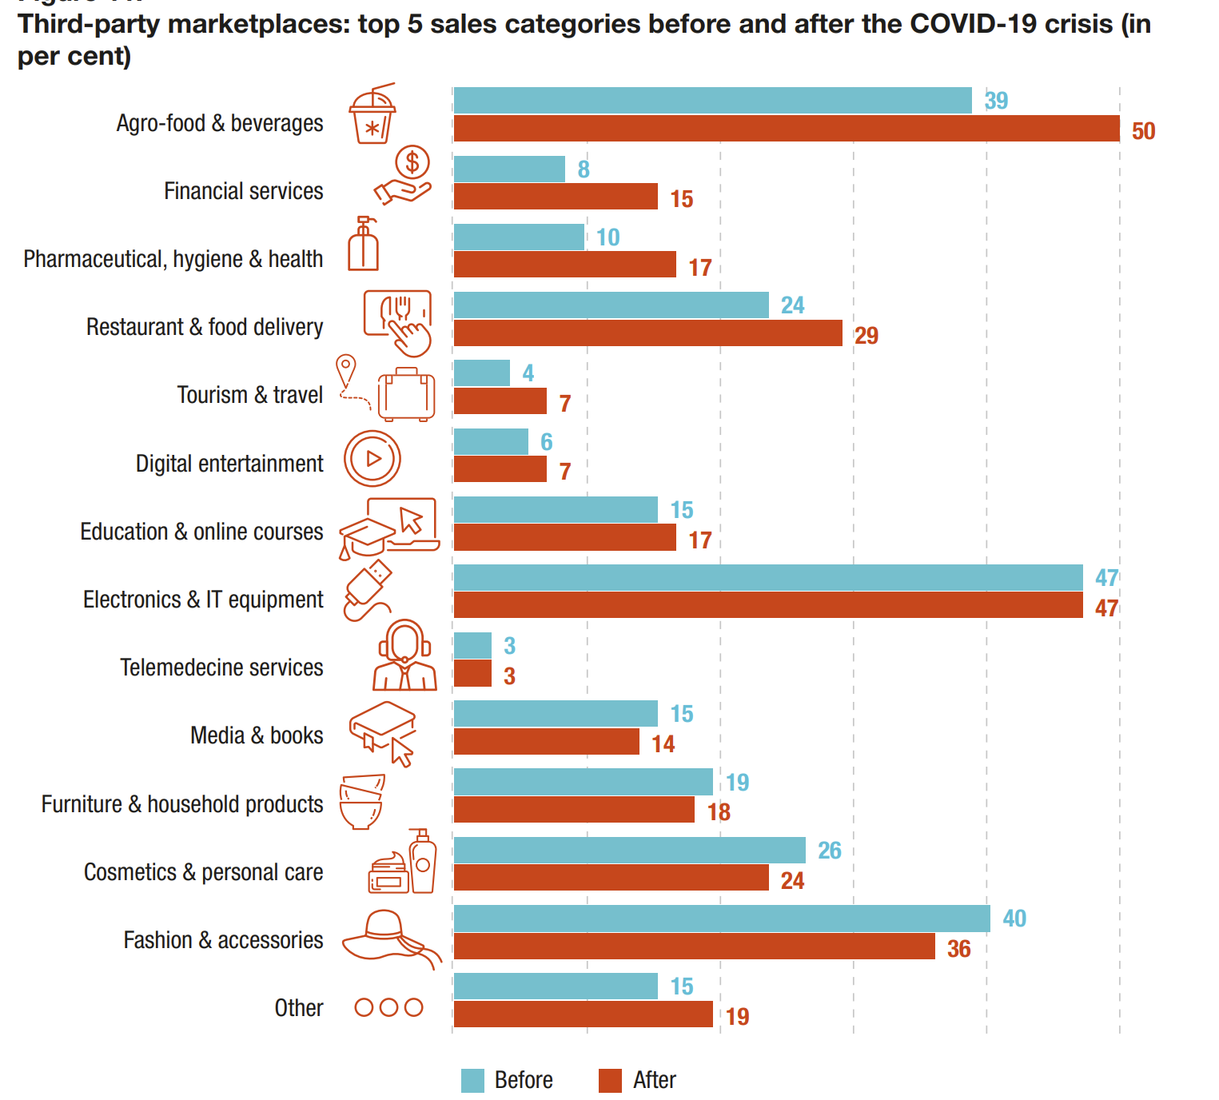

**BIBLOGRAPHY:**

* Business Analytics in E-Commerce: A Literature Review Xuemei Li
* Aloysius, J, C Deck and A Farmer (2013). Sequential pricing of multiple products: Leveraging revealed preferences of retail customers online and with auto-ID technologies. Information Systems Research, 24(2), 372–393.
* Liu, CC and YH Huang (2013). Prioritizing value measure of auction websites through users' perspectives. International Journal of Electronic Business Management, 11(2),144–155
* <https://unctad.org/system/files/official-document/dtlstictinf2020d2_en.pdf>

***Done By:***

***J.Shweatha***

***B.Sandhya***

***Riyanka Rajakumar***